**Experiment No. 02**

* 1. **Experiment Name**

Basic concept development on the idea of Simulink using MATLAB

* 1. **Objectives**
* To become acquainted with the Simulink platform and its’ libraries
* To learn how to implement Simulink libraries to design a system using MATLAB Simulink
* To get familiar with the procedure of designing a power system in Simulink
  1. **Apparatus**
* Simulink
  1. **Theory**

**2.4.1 Simulink**

Simulink is an application that allows you to simulate signals and dynamic systems. Simulink contains toolboxes for developing, simulating, and analyzing communication systems. In addition, source coding, channel coding, interleaving, analog and digital modulation, equalization, synchronization, and channel modeling are all possible with Simulink.

**2.4.2 Simulink Library**

The Simulink Library Browser is the library where you can locate all the Simulink blocks. Simulink software contains a large library of functions that are often used in system modeling. For this experiment following libraries were used,

**Constant**

It helps output the constant specified by the 'Constant value' parameter.

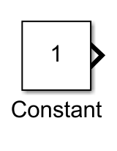

**Simplified Synchronous Machine pu Units**

Implements a 3-phase simplified synchronous machine. Machine is modeled as an internal voltage behind a R-L impedance. Stator windings are connected in wye to an internal neutral point.

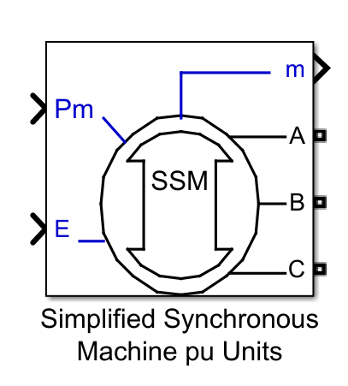

**Three-Phase V-I Measurement**

It’s an ideal three-phase voltage and current measurements block. The block can output the voltages and currents in per unit values or in volts and amperes.

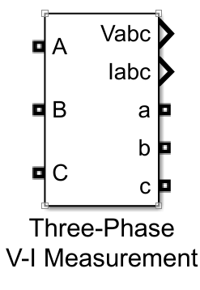

**Terminator**

This block is used to "terminate" output signals & prevent warnings about unconnected output ports.

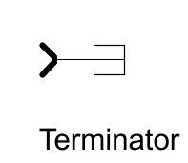

**Three-Phase Parallel RLC Load**

This block implements a three-phase parallel RLC load.

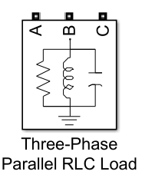

**Three-Phase PI Section Line**

This block models a three-phase transmission line with a single PI section. The model consists of one set of RL series elements connected between input and output terminals and two sets of shunt capacitances lumped at both ends of the line.

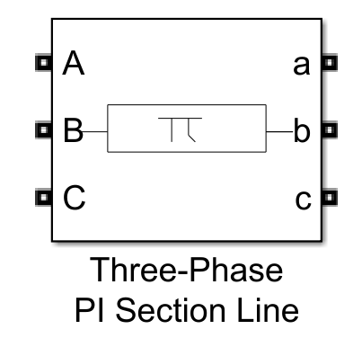

**Powergui**

This block help set simulation type, simulation parameters, and preferences.

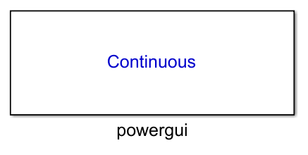

**Scope**

Its display’s output waveform.

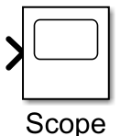

* 1. 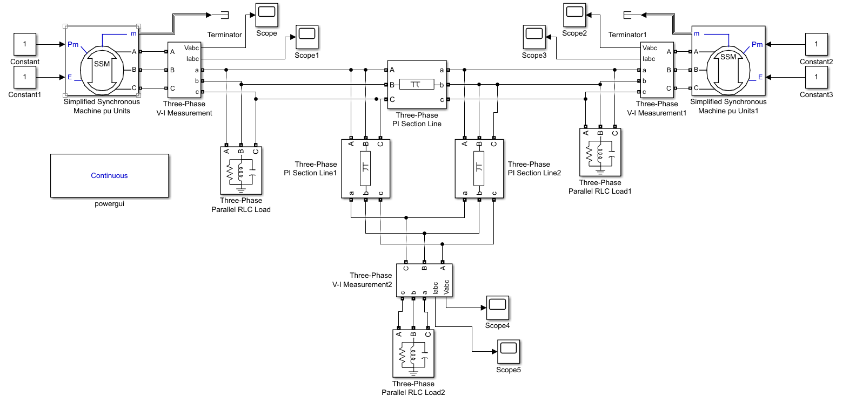**Block Diagram**
  2. **Output**

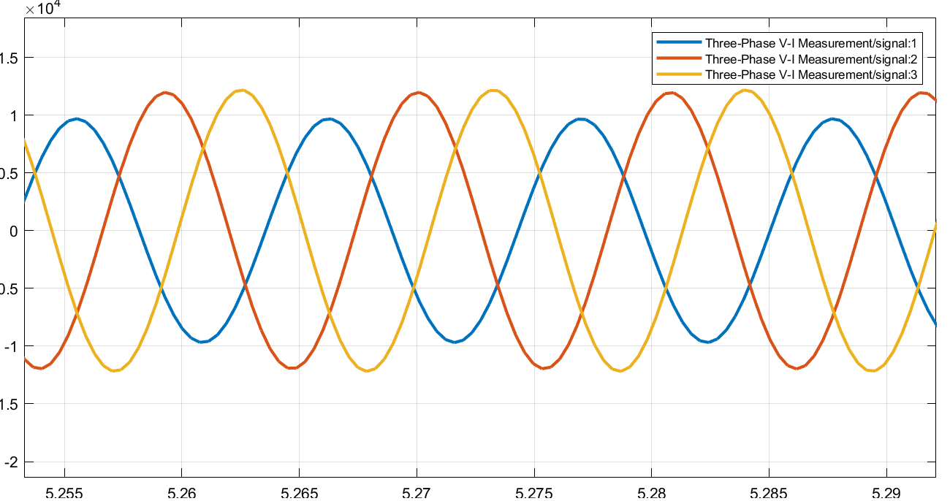

*Fig 2.1: Three- Phase Generator no.1 voltage signals*

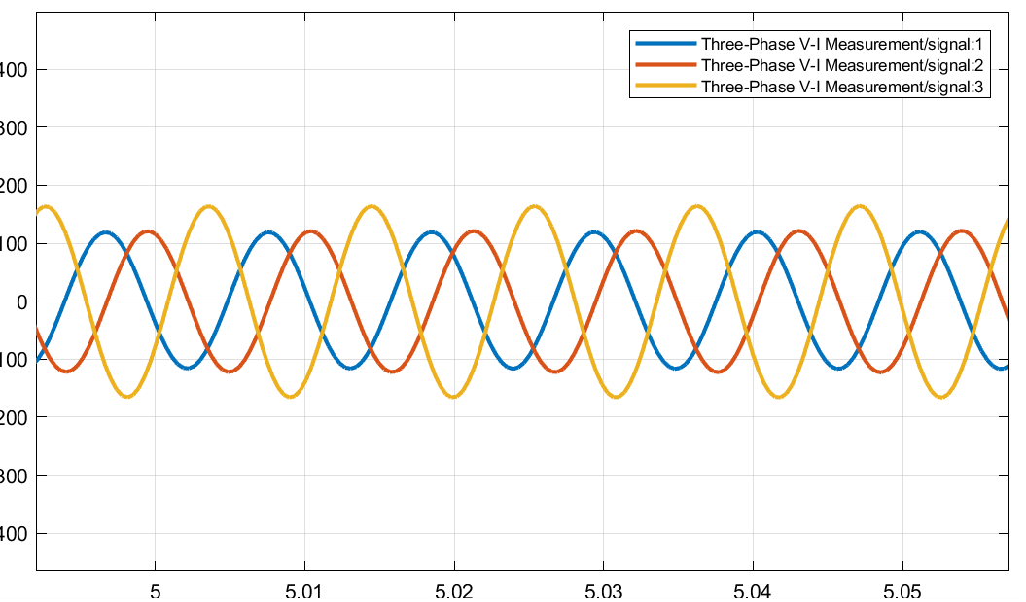

*Fig 2.2: Three- Phase Generator no.1 current signals*



*Fig 2.3: Three- Phase Generator no.2 voltage signals*

**

*Fig 2.4: Three- Phase Generator no.2 current signals*

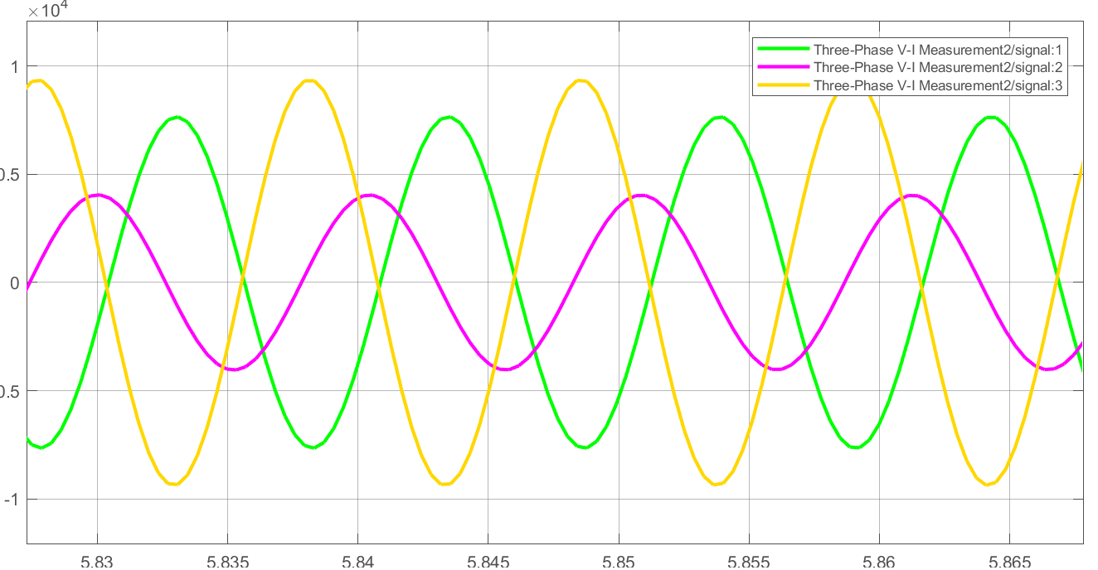

*Fig 2.5: Three- Phase parallel RLC voltage signals*

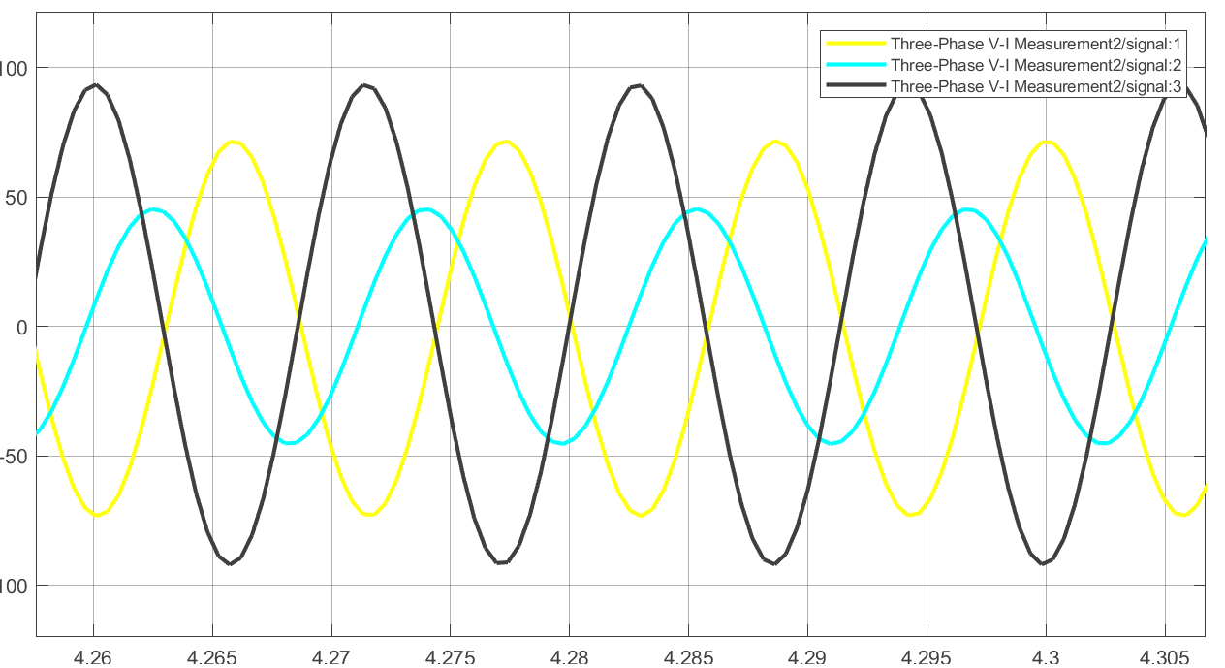

*Fig 2.6: Three- Phase parallel RLC voltage signals*

* 1. **Discussion & Conclusion**

In this experiment, we used the Simulink platform to design a three-bus power system. Various libraries and functions were implemented throughout the process. As a result, we become acquainted with the implementation and scope of the Simulink platform, as well as its libraries and functionalities. We also comprehended the system design process. As a result, the experiment's goal was achieved.